

DEEP BREATHING

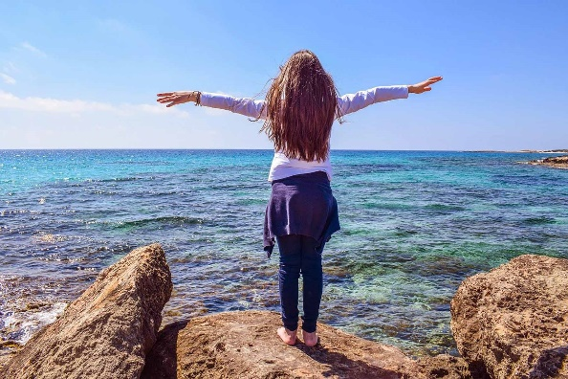

The Importance:

When a person is facing a threatening situation, the body naturally tenses up, assuming a “fight or flight” response. The threat may be real or imagined, but your nervous system sends signals to your body, causing muscle tightness, faster heartbeat and rising blood pressure, as well as faster, shallower breathing.

Over time, the repeated activation of this stress response takes its toll on your body, as well as your enjoyment of life.

The Remedy:

Fortunately, you can teach your body to be more relaxed; it’s easy, it’s free, and takes only minutes at a time. Have you ever noticed how you breathe when you feel relaxed? The next time you are relaxed, take a moment to notice how your body feels. Think about how you breathe when you first wake up in the morning or just before you fall asleep. Breathing exercises can help you relax, because they send a signal to your body that you are already relaxed.

Getting Started:

Inhale slowly through your nose, taking in so much air that you have to push out your tummy to make room for all the air. Hold the breath for a moment.

Release the breath, slowly through your open mouth, release all the breath so completely that you have to pull in your tummy to get all of it out.

Do this 3 or 4 times.

You Can Add Words:

***“I’m breathing in relaxation and rejuvenation, my breath is spreading oxygen throughout my body bringing energy and vitality to me****”*

And as you exhale: ***“I’m exhaling stress and tension from my body, feeling it leave me through my breath”***

And You Can Add Colors:

Try something soothing and healing like blues and pinks for relaxation and fiery reds and oranges perhaps for exhaling the stress. Something like this:

***“I’m breathing in relaxing blues and pinks to relax and rejuvenate my body, spreading oxygen throughout my cells, invigorating and relaxing my body and my spirit.”***

***“I’m breathing out the stress and anxiety in a rush of fiery red like a dragon! I feel all the stress and anxiety leave my body, swept away by the flow of red energy”***

Make It Yours:

You can choose any colors you like. Whatever works for you. You might want to start with just the breathing, and work your way up to adding words and colors. Use this as much and as often as you can. It’s a healthful way to destress and to reduce anger and anxiety.

You can also allow this to lead you to meditation:

Do this by sitting in a comfortable position. Place your open hands palms up, on your thighs and allow your body to relax. Do the breathing exercise several times. When you If you like, you can make a humming sound as you exhale by allowing your throat to vibrate.

 You might feel a bit dizzy from doing this…as one of my clients said, “so, you’re telling me to hyperventilate until the anger goes away?”  Not quite, but well, sort of, yes.